Lene Rock

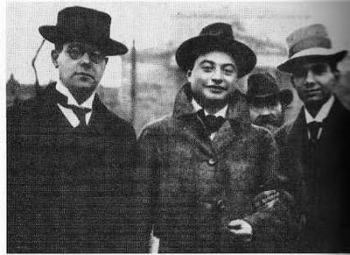**Pinthus, Kurt (1886—1975)**

Walter Hasenclever, Franz Werfel and Kurt Pinthus (Leipzig, 1912); in: Reiner Stach: *Kafka: The Decisive Years*. Houghton Mifflin Harcourt 2005; http://4.bp.blogspot.com/-URDp3pADn8U/Thd9Ao5UrTI/AAAAAAAAArQ/ve5lXrecq8Q/s1600/img157.jpg

Kurt Pinthus – pen name Paulus Potter – was a German-Jewish publicist, editor and critic, who is considered as one of the most important mediators of literary expressionism in Germany. He was born in Erfurt, studied literary history, philosophy and history and obtained his doctoral degree in 1910. As a proofreader and literary advisor at the Kurt Wolff and Rowohlt publishing houses, he contributed to the publication of authors like Franz Kafka, Else Lasker-Schüler, Georg Heym and Gottfried Benn. His anthology of expressionist poetry *Menschheitsdämmerung* (*Dawn of Humanity*,1919/1920) became an influential standard reference of literary expressionism. In 1933, Pinthus’ name appeared on the National Socialists’ list of banned literature. He fled to New York in 1937, eventually returning in 1967. Up until the 1970’s, his articles addressed life and work of writers persecuted by National Socialism.

**List of works**

* *Das Kinobuch* (1914)
* *Der Zeitgenosse: literarische Portraits und Kritiken ausgewählt zu seinem 85. Geburtstag am 29. April 1971* (1971)

**As editor:**

* *Neuer Leipziger Parnaß* (1912) (also contains Pinthus’ own poetry)
* *Deutsche Kriegsreden* (1916)
* [*Menschheitsdämmerung*](http://de.wikipedia.org/wiki/Menschheitsd%C3%A4mmerung)*. Symphonie jüngster Dichtung* (1919/1920); revised edition: *Menschheitsdämmerung. Dawn of Humanity. A Document of Expressionism. With Biographies and Bibliographies* (1959)
* *Georg Heym, Dichtungen* (1922)
* *Walter Hasenclever, Gedichte, Dramen, Prosa* (1963)

**References and further reading**

* Denkler, H. (1971) *Gedichte der Menschheitsdämmerung: Interpretationen expressionistischer Lyrik*, München: Fink.